**CHAPTER-1**

**INTRODUCTION**

**1.1 GENERAL BACKGROUND**

Robotics is the intersection of science, engineering and technology that produces machines, called robots, that substitute for (or replicate) human actions. A robot is the product of the robotics field, where programmable machines are built that can assist humans or mimic human actions. Robots were originally built to handle monotonous tasks (like building cars on an assembly line), but have since expanded well beyond their initial uses to perform tasks like fighting fires, cleaning homes and assisting with incredibly intricate surgeries. Each robot has a differing level of autonomy, ranging from human-controlled bots that carry out tasks that a human has full control over to fully-autonomous bots that perform tasks without any external influences. While the overall world of robotics is expanding, a robot has some consistent characteristic:

1. All robots consists of some sort of mechanical construction. The mechanical aspect of a robot helps it complete tasks in the environment for which it’s designed.

2. Robots need electrical components that control and power the machinery. Essentially, an electric current (a battery, for example) is needed to power a large majority of robots. Robots contain at least some level of computer programming. Without a set of code telling it what to do, a robot would just be another piece of simple machinery. Inserting a program into a robot gives it the ability to know when and how to carry out a task.

**1.2 OBJECTIVES**

In a large university office, administrative staff, executives or employees from multiple departments work together. They have to share hard copies of various confidential files or documents or other things with each other. They don't have to run around the building to share these files, freeing up their important and active work time. Therefore they depend on a peon as their helping hand. But in this era of technology an employee having responsibility of sharing files only is considered as wastage of human resource and also sometimes a peon can be a threat of confidentiality of the documents. In this situation, a robot can be an alternative solution to act as an office peon to share files among the staff.

The specific objectives of this project are:

1. To design and build a robot that safely moves files through a predefined path to a specified destination.

2. To reduce physical interaction between employees.

3. To avoid wasting human energy.

4. To foster work efficiency.

5. To reduce disorder in the school office and staff room.

6. To avoid file loss.

7. Keep the office secret.

8. For organized file exchange.

**1.3 SCOPE**

The robot has been designed to substitute the requirement for workers to transfer files or paper papers from one office to another office. The issue of human resource waste can be resolved. The biggest benefit of this robot is that it minimizes the amount of physical interaction between staff. The practicality, adaptability, economy, simplicity, ease of use, and durability of this robot are its advantages. The robot is a preferable alternative to the traditional manual exchanging carried out by employees because of the ordered transferring, prompt file delivery, and secrecy maintenance.

**CHAPTER-2**

**LITERATURE SURVEY**

Design and modelling of an autonomous mobile robot for material handling in the textile industry. The robot is designed to reduce manual human effort and increase efficiency in transporting processed cotton between different process stages. Potential industrial applications for this type of robot. The mobile robot is used to transport the processed material from the process station with the help of an autonomous mobile robot. The objective of project is to design and fabricate an autonomous mobile robot for Material Handling using photoelectric sensors with the help of painted strip guidance technology, thereby increasing productivity and reducing the workforce required for material handling. An emergency stop pushbutton is also there in the robot, which is placed at a reachable distance, which will stop the mobile robot immediately in case of emergency.[1]

The microcontroller-based mobile robot positioning and obstacle avoidance. It describes a hybrid navigation system that combines perception and dead reckoning to operate a mobile robot in a warehouse. The paper also discusses the design of a microcontroller system to control the robot's movements and the use of 24 ultrasonic sensors at 22.5 degree for obstacle avoidance. The task of combining sensor information into a usable form for navigation decisions is known as sensor fusion.

In almost all robot systems, multiple sensors from the same type or different types are used to give complete coverage, for example a ring of 24 ultrasonic sensors in 15 degree increments around a vehicle, mobile robot CARMEL. Another example is the Nomad Supper Scout II which carries 16 ultrasonic sensors separated by 22.5 degree around the vehicle. Mobile robots generally carry dead reckoning sensors such as wheel encoders and inertial sensors and also landmark and obstacle detecting and map making sensors such as time of flight ultrasonic sensors. Vision sensors are used in many applications to build an image of the space confronting the mobile robot in order to detect any obstacle and avoid collisions.

The robot description and the sensors, decoders and encoders built on the robot while describes the robot controller designed for robot operation with the ultrasonic sensors used clustering and the controller hardware and software. Robot description the mechanical design for the robot plays a critical role in the success of the robot facility. The robot will use a battery assembly with total volt 48 V. The control unit and battery charger should be on the robot itself.

Robot positioning Methods for robot positioning can be roughly categorized into two groups: relative and absolute position measurements. The robot senses the obstacles using its sonar sensors. The selection of the range effects on the sensitivity of the sensors or in other meaning the evaluation to the distance between the robot and the obstacle from the point of view if it is dangerous or not. We need the front sensors to be more sensitive than the Front- Right and Front-left to protect the robot from collision with the walls or obstacles during turning at the walls corner or turning around the obstacle to avoid it.

There are several rule bases according to sensors readings and odometer that make the robot switch from one controller to the other. Robots motion types The robot vehicle is designed to perform only two distinct kinds of motion in the warehouse: Straight-line motion, where both motors are running at the same speed and in the same direction. Motion inside the warehouse The difference between the readings of the two side sensors L = SL1 &SL2 are used to help the robot to align to the left wall. The controller system should be able to accomplish simultaneously the right operation of the robot while taking care of the safety of the system.

The ultrasonic ranging subsystem requires a dedicated controller which can accurately report the distances to the nearest objects for all the installed ultrasonic sensors in response to a high level "Range Find" command issued by the robot master. During its navigation, the robot reads continuously the sensors readings. If the robot detects a part of the wall in the left or right, depending on the set of sensors that detects an obstacle, he has to manoeuvre to put itself in the right position in front of the door before getting in: First, he has to go backward for about 50 cm. The sensory system used is composed of wheel encoders and ultrasonic sensors to correct the position of the robot resulting from odometer system and to avoid any obstacles during navigation.[2]

The use of ultrasonic sensors for obstacle detection in mobile robots. The article highlights the benefits of using ultrasonic sensors, such as low cost and flexibility, and presents experimental results showing the reliability of the system. There have been a number of successful attempts in designing obstacle avoiding robots. Experimental results with varied positions of obstacle show the flexibility of the robot to avoid it and have shown a decent performance in our laboratory. These works differ by selection of sensors, path mapping process and the algorithms applied to set the operational parameters. In obstacle detection, the selection of sensor is vital for the required application of the robot, otherwise, it might fail to operate even though all hardware and software are working properly. A robot with optical sensors in a room with glass walls might create more collisions than avoidance. Applied low cost sensor network for avoiding obstacle using RGB and Infrared camera and ultrasonic sensors which can detect different obstacles also obstacle warning and avoidance system.

Mobile robot localization using camera and ultrasonic sensor to get the location data and detection and tracking system for mobile robots which achieved a good recognition rate. The ultrasonic sensor enables the robot to pretty much observe and recognize a protest, maintain a strategic distance from impediments. Conclusion Obstacle avoidance capability needs to be considered when designing mobile robots for different applications. The low cost ultrasonic sensor for mobile robot is aim to design and implement a helpful tool that improves the ability of mobile robot to avoid obstacle successfully. [3]

A Type-1 fuzzy logic and interval Type-2 fuzzy logic controllers were designed and implemented for a swarm robot system. The experimental simulation results have shown that the complex problem modelling Type-2 fuzzy logic has better performance than Type-1 fuzzy logic. Hierarchical fuzzy controllers based on Type-2 Fuzzy Logic System for mobile robot in a partially known environment with eight sensors.

Type-2 of Fuzzy Logic System The typical architecture a Type2 fuzzy logic controller is similar to that of a Type .The typical architecture of a Type2 fuzzy logic controller is similar as to shown that of a Type1 1 fuzzy logic controller, but with an extra step, which is called type reducer, fuzzy logic controller, but with an extra step, which is called type reducer. Fuzzy rule inputs base: The rules in a Type-2 fuzzy Fuzzifier: It converts crisp into Type-2 fuzzy sets. Logic stay the same as in a Type-1 fuzzy logic, but antecedents and consequents are fuzzy sets. Fuzzy rule base: The rules in a Type2 fuzzy logic stay performed the same by as Type2 in a Type1 fuzzy inference engine: It assigns membership functions by using the rules in the rule logic, but antecedents and consequents are performed by Type2 fuzzy sets. As union and the intersection to drive Type1 fuzzy To obtain scalar crisp fuzzy control operation action, one must apply the defuzzification process based on one-dimensional fuzzy control action vector.

Can determine the completeness of the fuzzy rules which are The Type-2 fuzzy logic controller block has three main processing parts: specific applications, a set of 63 fuzzy prod The simulation results proved the robust manner of the Type-2 fuzzy logic controllers over the Type-1 fuzzy logic controller when the same operating conditions were used regarding the obstacle-avoidance case. The sensors' readings were fed to the obstacle-avoidance Type-2 fuzzy logic controller as crisp voltage inputs that were fuzzified into three fuzzy sets each. A Type-2 Fuzzy logic controller with 63 fuzzy rules was designed to control Robot guiding. The fuzzy actions based on the TSK Type2 fuzzy algorithm were used to control the linear velocity along the x-direction, along with the angular velocity.[4]

The Wheeled Mobile Robot the motion control problem of an autonomous wheeled mobile robot has been widely investigated in past decades. The combination of four sharp infrared sensors is equipped on the robot to read the obstacle distance, and this distance information is fed to the controller to adjust the speed of two separate motors of the robot. Various Soft Computing Techniques used for Mobile Robot Navigation In the past few years, many soft computing techniques are proposed by the researchers to solve the robot navigation and obstacle avoidance problem in the various environments.

Fuzzy Logic Technique for Mobile Robot Navigation The concept of fuzzy logic has been used , which is extensively used in many engineering applications such as mobile robotics, image processing, etc. Fuzzy PWM controller has been used for mobile robot navigation and obstacle avoidance in an unknown environment. Have presented the fuzzy behaviour controller for mobile robot navigation in the densely obstacle populated environments. Have developed a genetic fuzzy technique based on a combined approach of genetic algorithm and fuzzy logic to solve the mobile robot motion planning problems in the dynamic environments.

Juang & Hsu have designed the reinforcement ant optimized fuzzy controller and applied it for wheeled mobile robot wall-following control under reinforcement learning environments. Mobile Robot Navigation and Obstacle Avoidance Techniques: A Review following mobile robot has been controlled by two type-2 fuzzy controllers.

Brand & Yu have applied the Firefly Algorithm to find a collision free shortest path in the two dimensional static and dynamic environment for a mobile robot. Have presented a new Random Particle Optimization Algorithm, which is inspired by the bacterial foraging technique, and used for local path planning for mobile robots in the dynamic and unknown environments. Have been applied by the researchers for mobile robot navigation and obstacle avoidance in the different environments. According to literature survey, most of the researchers have used these soft computing techniques for mobile robot navigation and obstacle avoidance in only static environments.[5]

**CHAPTER-3**

**Methodology**

**3.1 Methodology**

Class Assist robot is a wheeled robot for securely transferring files in a typical college and school environment. The robot moves through a pre-defined path to the intended destination using IR sensor.

The robot also has the ability to detect obstacles in its path. The ultrasonic sensor assesses the obstacle's distance as the robot approaches it by sending out ultrasonic sound waves, and it turns the reflected sound into an electrical signal. The sensor measures the amount of time that passes between the transmitter's sound emission and its contact with the receiver in order to determine the distance between the obstacle and the sensor. D = ½T*C (where D is the distance, T is the time, and C is the sound speed, which is 0.0343 mm/s) is the formula to use for this computation. The robot will halt and raise the alarm if the measured distance is 20 mm or less. Thus, this device helps reduce human involvement and time consumption in an office environment.

**3.2 Block Diagram**

The Fig 3.1 shows the block diagram representation of the entire robotic system. Arduino Mega 2560 is the microcontroller used in this project. It is connected to the RFID detection module, the IR sensors, the ultrasonic sensor, the servomotor and the L298n motor driver which connects to the four gear motors for motion control. The Arduino is also connected to another IR sensor to detection of file. The robot will use an ultrasonic sensor to detect obstacles in its path and navigate around them, ensuring safe and efficient movement. Additionally, the robot will utilize an IR sensor to follow a line, allowing it to navigate through predetermined paths with precision. The methodology involves integrating these sensors with the robot's control system and programming it to respond appropriately to sensor readings. Through this combination of sensors and control systems, the robot will be able to perform its tasks autonomously and with high accuracy, making it an effective tool in the college and helping to reduce human involvement.

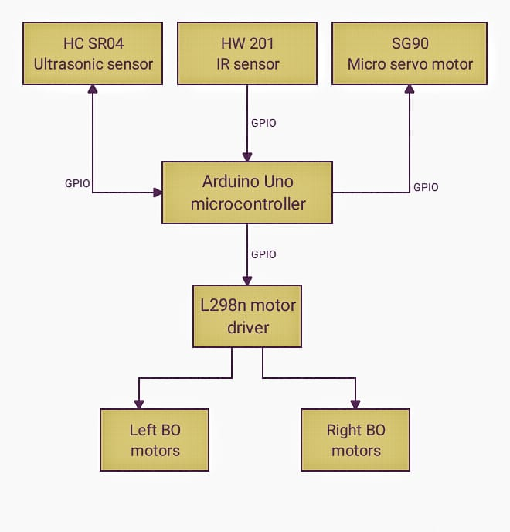

**Fig 3.1: The Block Diagram**

**3.3 Component Description**

The following components required:

1. Arduino Uno ATmega328P

2. Ultrasonic sensor

3. IR Sensor

4. Motor driver

5. BO DC Motors

6. Battery

**3.3.1 Microcontroller**

A microcontroller can be considered a self-contained system with a processor memory and peripherals. It can be used as an embedded system. In simple words, it contains an integrate processor, memory and programmable input or output peripherals which are to be used to interact with the various components connected to the chip.

The microcontroller used here is Arduino UNO ATmega328P which based on the ATmega328P, an 8-bit microcontroller with 32KB of Flash memory and 2KB of RAM. All of the modules can work together or separately.

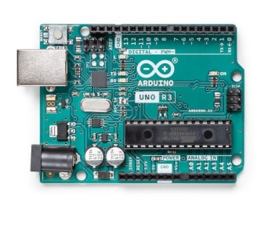

**Fig 3.2: Arduino UNO ATmega328P**

**3.3.2 The HC-SR04 Ultrasonic Range Sensor**

The HC-SR04-Ultrasonic Range Finder is a very popular sensor that is found in many applications where it requires measuring distance and detecting objects. This Ultrasonic Sensor module is a transmitter, a receiver, and a control circuit in one single board It has very handy and compact construction. It offers excellent range accuracy and stable readings.

The Trigger and the Echo pins are the I/O pins of this module and hence they can be connected to the I/O pins of the microcontroller/Arduino. When the receiver detects the return wave the Echo pin goes high for a particular amount of time which will be equal to the time taken for the wave to return back to the sensor. Ultrasonic Ranging Module HC-SR04 provides 2cm-400cm non-contact distance sensing capabilities with ranging accuracy up to 3mm.

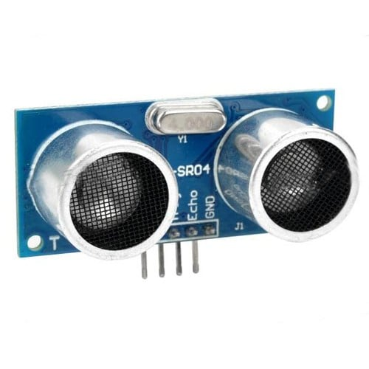

**Fig 3.3: HC-SR04 Ultrasonic Sensor**

**3.3.3 IR Sensor**

IR Infrared (Active Low) has a pair of infrared transmitting and receiving tubes. When the transmitted light waves are reflected back, the reflected IR waves will be received by the receiver tube. The module features a 3 wire interface with VCC, GND, and an output pin on its tail. It works fine with 3.3 to 5V levels. Upon hindrance/reflectance, the output pin gives out a digital signal (a low-level signal). The on-board pre-set helps to fine-tune the range of operation, the effective distance range is 2cm to 30cm.

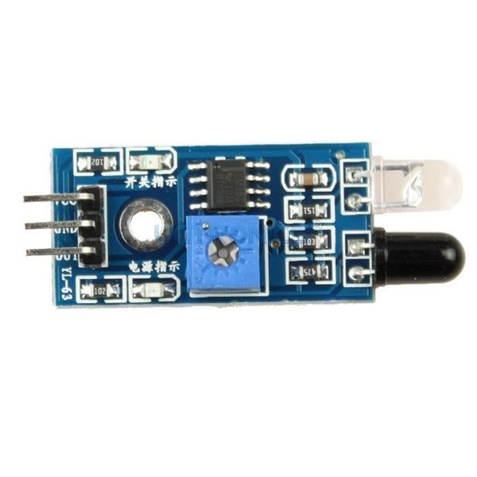

**Fig 3.4: IR Sensor**

**3.3.4 Motor Driver**

The motor driver used in this proposed system is L298N. This L298N Motor Driver Module is a high power motor driver module for driving DC and Stepper Motors. An L298 motor driver IC and a 78M05 5V regulator make up this module. Up to 4 DC motors or 2 DC motors with speed and direction control can be controlled by the L298N Module. The twin H-Bridge motor driver L298N enables simultaneous speed and direction control of two DC motors. The module can run DC motors with peak currents up to 2A and voltages between 5 and 35V.

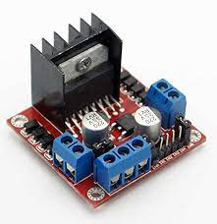

**Fig 3.5: L298N Motor Driver**

**3.3.5 BO DC Motor**

DC Motor used is 150rpm and 3V – 12Volts geared motors. It gives a massive torque. These are generally a simple DC motor with a gearbox attached to it. This can be utilized in a wide range of robotic applications, including all-terrain robots.

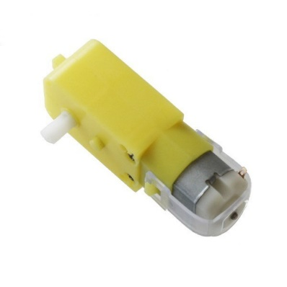

**Fig 3.6:BO DC Motor**

**3.3.6 Li-Po Battery**

The battery used is 3.7V 1200mAH lithium polymer battery. It is a rechargeable battery and provide higher specific energy than other lithium battery types. They are also far more effective and efficient at storing power, have low internal resistance, and have exceptional low discharge abilities..

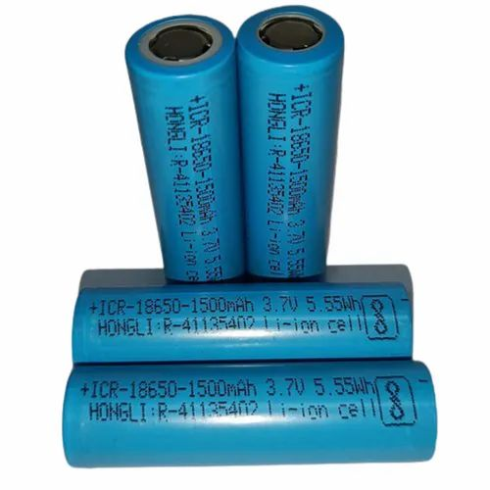

**Fig 3.7: Li-Po Battery**

**3.4 Circuit Diagram**

The Fig. 3.7 shows the circuit diagram of the proposed system. The battery used to power the microcontroller Arduino UNO ATmega328P is 3.7V 1200mAH lithium polymer battery. Same battery source is use to power L298N motor driver through which two pair of parallel connected battery operated DC motor. L298N motor driver is connected to microcontroller Arduino UNO ATmega328P through GPIO to control the motor. Microcontroller have GPIO connection four IR sensor ,ultrasonic sensor and micro servo motor.Three IR sensor are for the line following and last one is for the check the presence of file on the tray of robot .The ultrasonic sensor is mounted on micro servo motor which placed on front of robot to detect the obstacle.

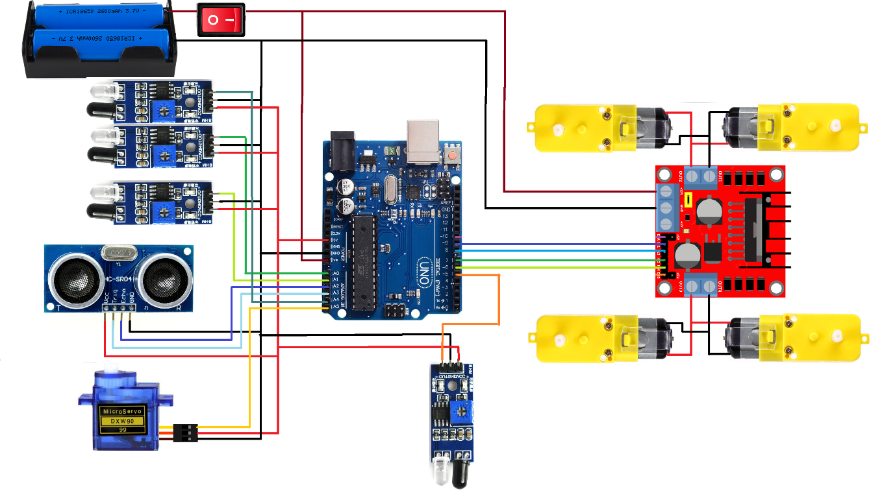.

**Fig 3.8: The Circuit Diagram**

**CHAPTER-4**

**Project Implementation and Results**

**4.1 Project Implementation**

The robot’s main system is the data processing of entire input system. Input system consist of IR sensor and ultrasonic sensor. The robot will move to the caller’s workstation by processing and reading line on the corresponding classroom. Microcontroller has the most important role in data processing of the entire robot’s system.

**4.2 Hardware Views**

The Fig 4.1 The mechanical design of the wheeled mobile robot. The top view show the top of the mobile robot along with the dimension and front view show front of the mobile robot along with the dimension and side view show side of mobile robot along with the dimensions.

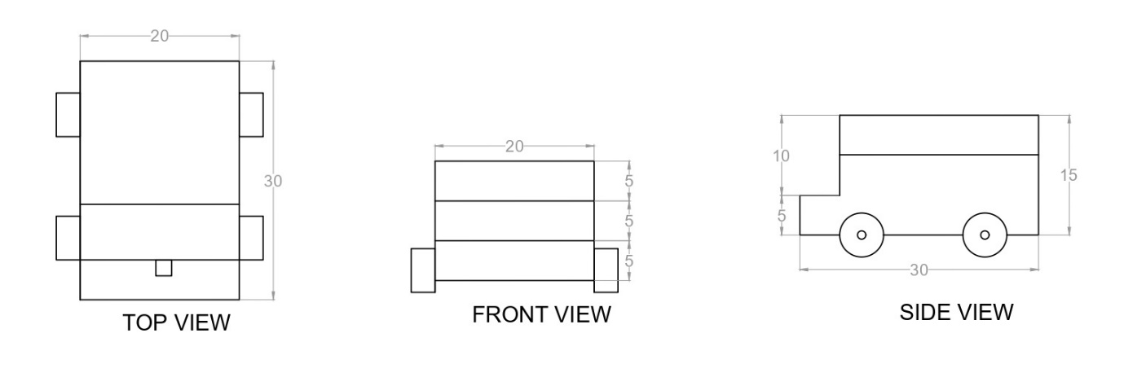

**Fig 4.1: The Mechanical Design**

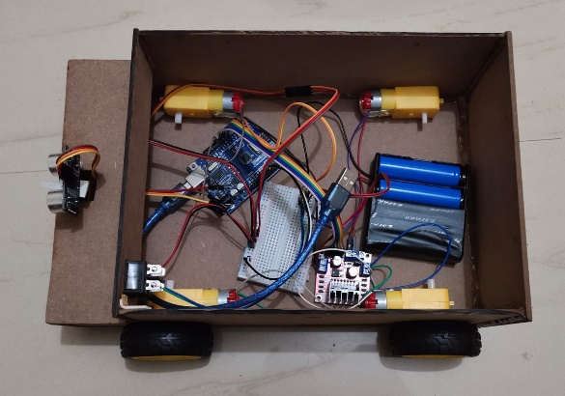 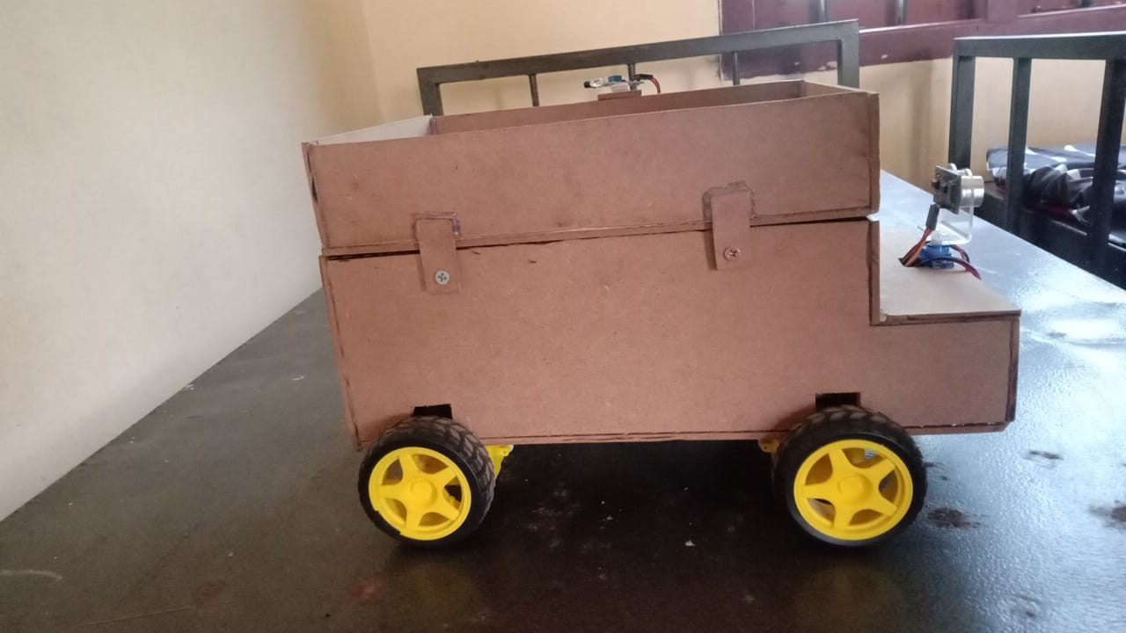

**Fig 4.2: Chassis Fig 4.3: Side View**

**4.2 Software View**

The Fig 4.4 Flowchart show the how mobile robot move from initial base station to intended classroom and wait till file is removed by authorised person and then return back to the base station .

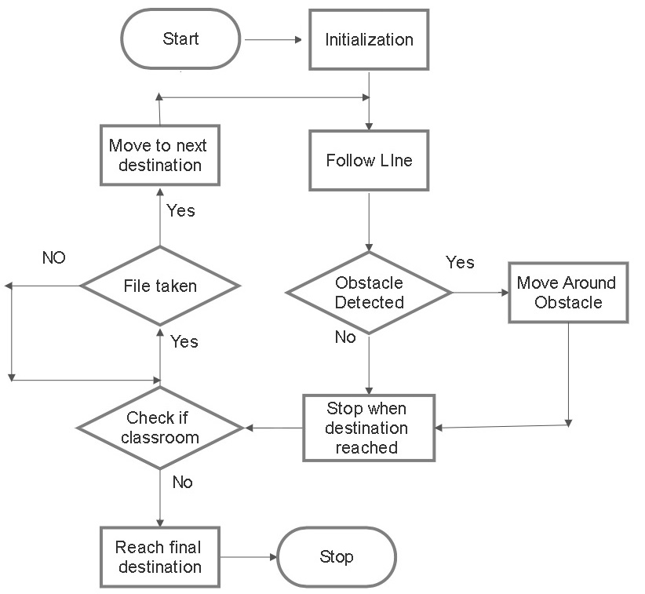

**Fig 4.4: Flowchart**

**CHAPTER-5**

**Conclusions**

**5.1 Conclusion**

The prototype of the system developed here can share file among a few classroom and staffroom. But the design can be enhanced for large number of the classroom. Use of this robot in college make the college environment more efficient, working friendly and faster. This system is applicable for carrying documents or goods within the places at the same floor.

**5.2 Recommendation**

The prototype of the system can developed to deliver the files and other important light weight cargo like stationary supplies etc to classrooms and others buildings within the campus premises.

**5.3 Scope for Further Work**

In future the system can be developed to do the same task within the places of several floor and may be it can be develop to do the file transfers throughout the college campus from department to another department.

**REFERENCES**

1. Madhankumar, S., Anandraj, P., Varadarajan, A., Kumar, R.A. and Kaleeswaran, K., 2021, March. Design and Modelling of Autonomous Mobile Robot for Material Handling. In *2021 7th International Conference on Advanced Computing and Communication Systems (ICACCS)* (Vol. 1, pp. 738-742). IEEE.
2. Zaki, A.M., Arafa, O. and Amer, S.I., 2014. Microcontroller-based mobile robot positioning and obstacle avoidance. *Journal of Electrical Systems and Information Technology*, *1*(1), pp.58-71.
3. Azeta, J., Bolu, C., Hinvi, D. and Abioye, A.A., 2019, November. Obstacle detection using ultrasonic sensor for a mobile robot. In *IOP Conference Series: Materials Science and Engineering* (Vol. 707, No. 1, p. 012012). IOP Publishing.
4. Al-Mallah, M., Ali, M. and Al-Khawaldeh, M., 2022. Obstacles Avoidance for Mobile Robot Using Type-2 Fuzzy Logic Controller. *Robotics*, *11*(6), p.130.
5. Pandey, A., Pandey, S. and Parhi, D.R., 2017. Mobile robot navigation and obstacle avoidance techniques: A review. *Int Rob Auto J*, *2*(3), p.00022.